PERFORMANCE AND FINAL SUBMISSION PHASE

|  |  |
| --- | --- |
| **DATE** | 1.11.2023 |
| **TEAM ID** | NM2023TMID08660 |
| **PROJECT NAME** | Create a brand name, brand email and brand  logo using canva |

STEP:1 Create an EMAIL account for your brand.

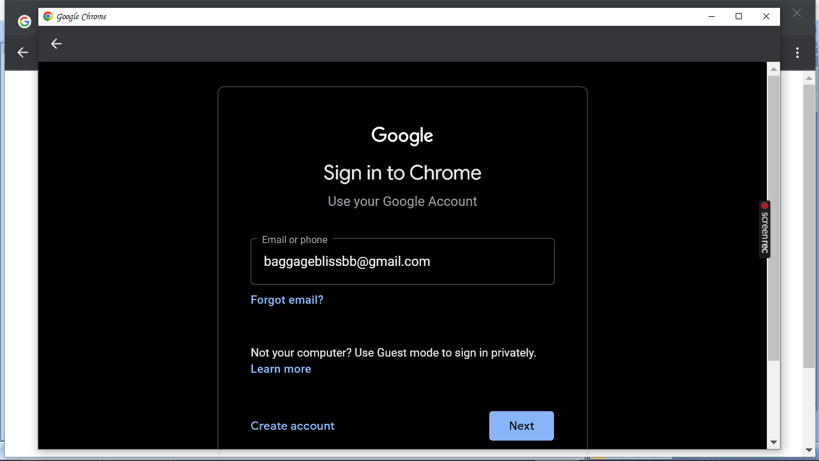

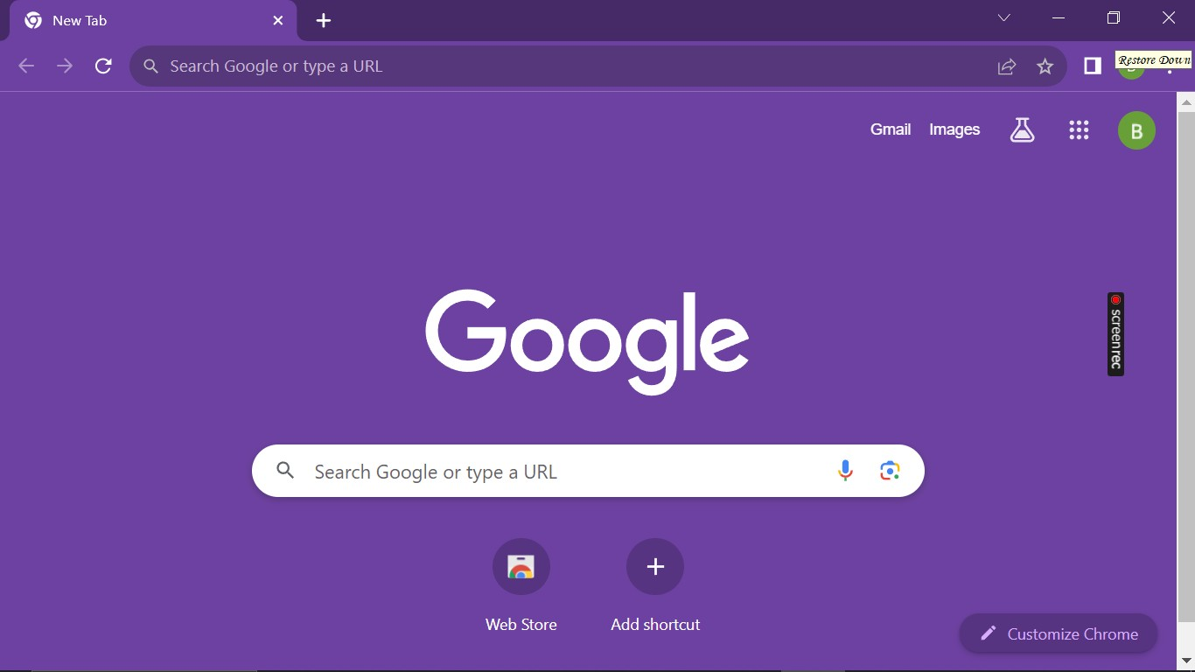

STEP:2 Open a web browser and search canva’s website.

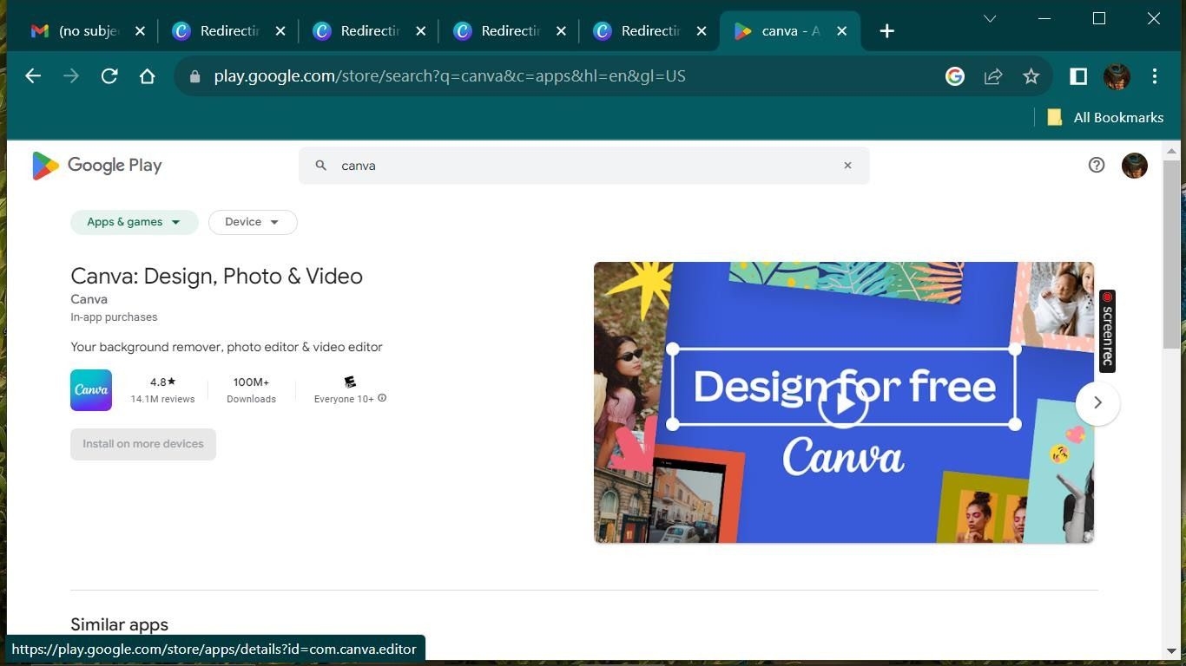

STEP:3 If you already have a canva account, “LOG IN”.If not,you can sign up for a new account using email id,google or facebook.

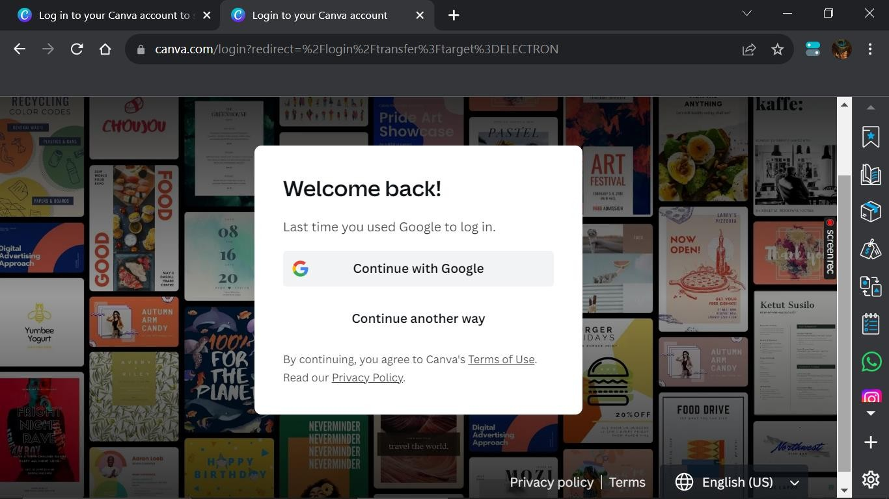

STEP:4 After login open canva’s application and click on “Create a design” at the top right corner.

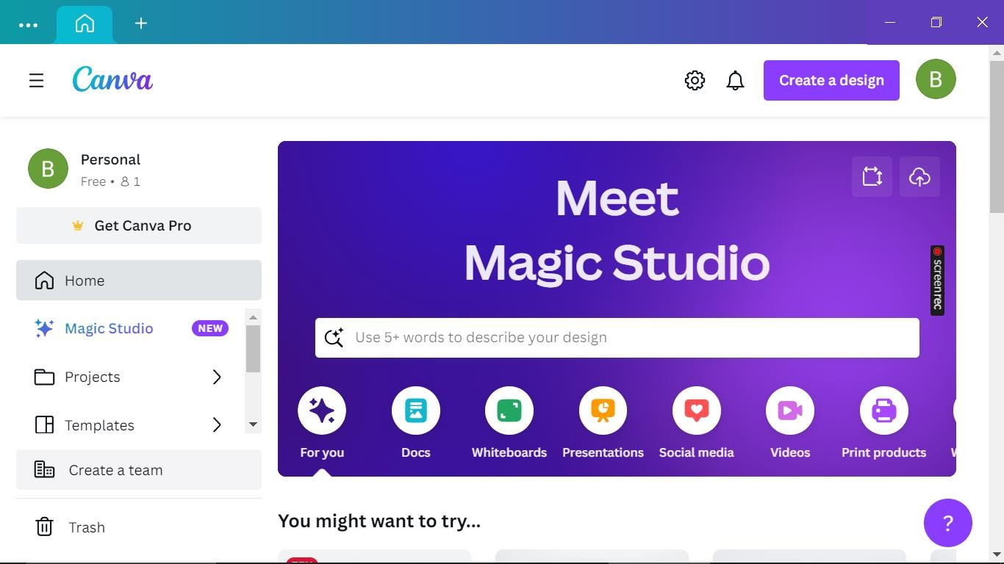

STEP:5 In the search bar at the top of the page type”logo template”.

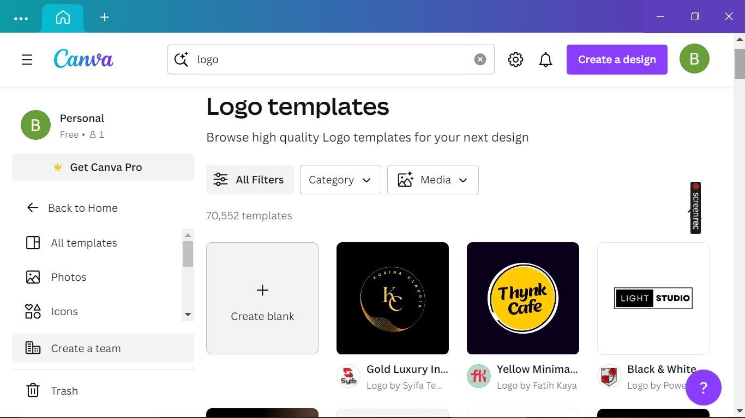

STEP:6 Click on a template that you want to use. It will open in canva design editor, where you can customize it with your own text, image and elements.

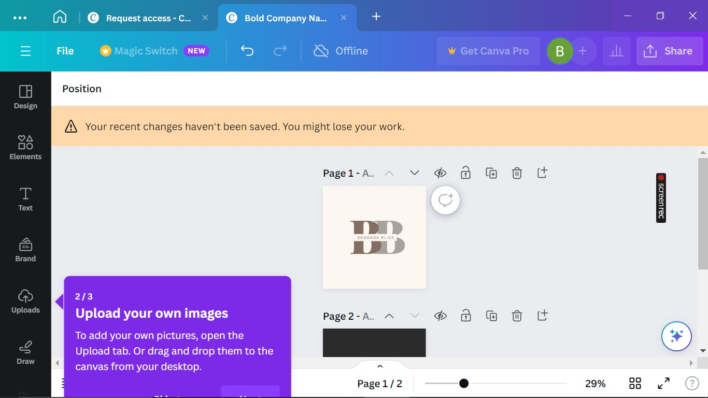

STEP:7 Once you have customized your logo, click “Download”.

